Assignment 4

Chaiwat Plongkaew 2021326660023

telnet mail.hust.edu.cn 25

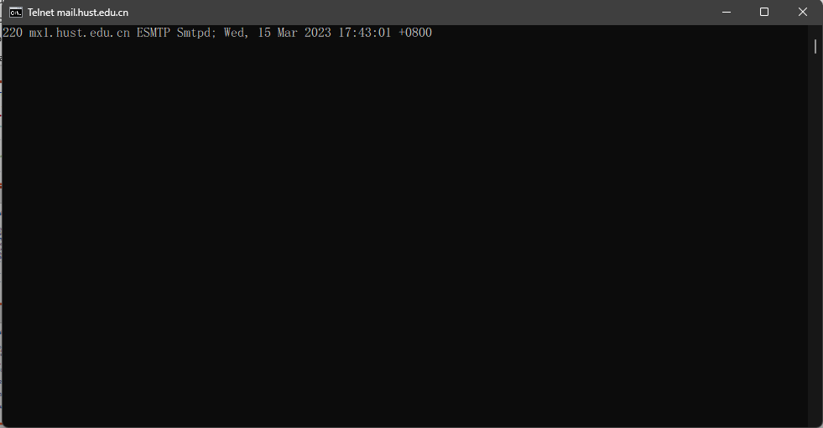

telnet cs.hust.edu.cn 80

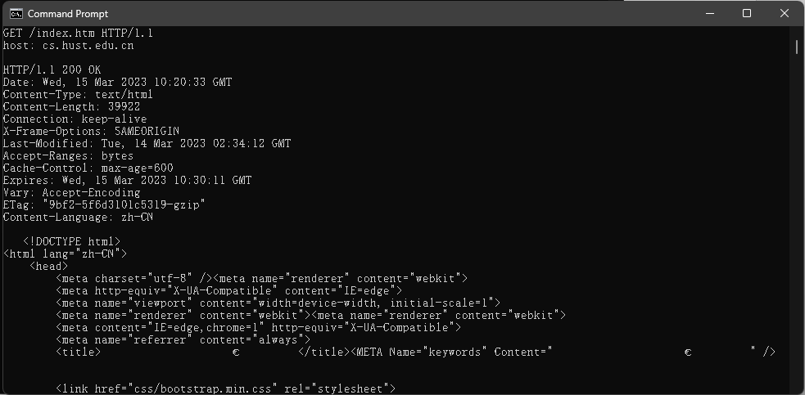

**P2. SMS, iMessage, WeChat, and WhatsApp are all smartphone real-time messaging systems. After doing some research on the Internet, for each of these systems write one paragraph about the protocols they use. Then write a paragraph explaining how they differ.**

SMS or Short Message Service is a text messaging component of most mobile device systems, and the message can up to 160 characters only. SMS exchanges messages with telephone operator gateways via the Short Message Peer to Peer (SMPP) protocol. Cell phones that support GSM, UMTS, iDEN, CDMA, and TDMA employ SMPP to deliver and receive messages. The control channel, which is the communication channel between your cell phone and your phone tower, is reached by radio waves. SMS texts can now be sent and received on mobile devices. The iMessage protocol is based on the Apple Push Notification service (APNs), binary protocol. iMessage is available on Apple devices, it provides free messaging between Apple devices. If an iPhone user sends a message on iMessage to a non-Apple device, it will be converted to a SMS. iMessage requires an internet connection to send a message. WeChat used a proprietary encryption protocol called as MMTLS for its most communication. MMTLS protocol is draft for both performance and security, it is suitable is suitable for scenarios of low latency and lightweight messaging. We categorize seven common activities that are encrypted by the MMTLS protocol using the WeChat traffic that has been gathered from various platforms (Android, iOS) and devices (Huawei, Samsung, iPhone, iPad, etc.) by various users. These activities include payments, ad clicks, browsing sessions, and so on. WhatsApp uses XMPP (extensible Messaging and Presence Protocol) to handle the message delivery system. XMPP is mostly like HTTP where the client opens the socket with the XMPP server and keeps it open as long as the client is logged in. This protocol designed for instant messaging, it enables the near-real-time exchange of structured data between two or more network entities.

**P20. Write a simple TCP program for a server that accepts lines of input from a client and prints the lines onto the server’s standard output. (You can do this by modifying the TCPServer.py program in the text.) Compile and execute your program. On any other machine that contains a Web browser, set the proxy server in the browser to the host that is running your server program; also configure the port number appropriately. Your browser should now send its GET request messages to your server, and your server should display the messages on its standard output. Use this platform to determine whether your browser generates conditional GET messages for objects that are locally cached.**

**Ans**

**The Last modified field on both packets in the same, so it means browser will create conditional GET messages for the objects.**



